**CHAPTER ONE**

**INTRODUCTION**

* 1. **BACKGROUND OF THE STUDY**

Design and implementation of online banking system, a case study of Guarantee Trust Bank.

The greatest innovation that has taken place in the twentieth century is in the realm of information Technology. This is currently made possible by the introduction of the digital computers which has been observed in the field of communication to be increasingly inseparable from communications. These linkages often referred to as convergence is driven by technology and amplified by business trends. Faster growth in network systems that use communication links to connect subsidiary system (nodes) which may send and receives, direct and redirect information.

Talking of the internet a couple of years ago would have sound like a fairytale but today the internet is pervasive in almost every field of human Endeavour changing the fundamentals of how we conduct national as well as international businesses. Few years of its existence, the internet has shown that it can deliver the long sought after goal of electronic commerce.

It is worth that companies in the developed countries world-wide have recognized the business potential of the internet and are getting connected to the network of networks in their millions.

The financial institution (Bank) is one of such organizations. Banking constitutes one of the most prominent life wire for Socio-Economic grow and development in any given nation, it supports and assists in the supply of long and short term loan, accepts both current sowing and fixed deposits, both foreign transactions, advice and facilitates transactions between client, workers, agents, firm, buyers and seller by providing payment services, not excluding the issue of undertaking risk on behalf of their clients, only to mention but a few.

The internet having found its application and acceptance in the banking procession has particularly put the banking industry on an accelerating pace of development. The technological highway (the internet) has become an enabler for Banks in achieving high level productivity and in handling volumes of transaction which would have been impossible without the use of on-line banking (E-commerce).

The technology facilitates linkages with clients both through the provision of information and quality service delivery, as well as in reducing barriers to entry into payment systems retail banking. Internet banking allows clients to engage in informal transaction relationship which would have taken long distance travels or movement of documents with the attendant risk of loss. With the online banking (internet) you can at your convenience, at home and at any time review account balances and transactions, transfer funds, receive and pay bills, down-load transaction services and contact customer services just to mention but a few.

An over view of the benefits and prospects of the on-line banking suggest that for banks to be relevant to their customers in term of the services they provide in the twenty-first century and in the future, must append this services provided by E-commerce in the banking system in order to stay in competition. Now the on-line banking is the one thing bank should get up and invest in internet technology to reap bounteously the benefit accruing from internet banking.

While Internet continues growing and gaining popularity among crowd, mobility represents new challenges to web designers. Wireless access is a new challenging mission in the current Internet era, with different demand for information by using less efficient terminals and networks. What really motivated our choice of topic was the fact that Information and Communication Technology (ICT) is not yet fully applied in Guarantee Trust Bank and in our economy as a whole. We felt that Guarantee Trust Bank Branch should also exploit the use and application of this wireless system in order to enhance their operations effectively and efficiently.

**1.2 STATEMENT OF PROBLEM**

In banking industries today, queuing has become the order of the day, customers’ line up for hours waiting. A lot of problem for customers as they waste their useful time in the banking hall. The management also wastes their time as they run around to find solution to those problems. Also it is observed that customers cannot withdraw money

Anytime they want as banks has their working hours. This is a big problem as needs can arise at any time and human beings will always like to have those needs solved. Also money deposited into accounts at times takes some hours to reflect in the person’s account balance hence making banking operations slow and unhealthy for business growth.

Information and Communication Technology is still underutilized in Guarantee Trust Bank and in our society as a whole. Guarantee Trust Bank lacks effective ICT capacity for dynamic wireless operations. On analyzing the existing system of branch, the following problems were identified:

1. Guarantee Trust Bank lacks the Information and Communication Technology (ICT) capability to wirelessly operate and interact with their database in order to:

* Verify whether an account is credited or debited, wirelessly using GSM handset or internet.
* To verify the status of a Customer.

1. Guarantee Trust Bank, can verify the validity of their customers only through one source in a whole Branch through on central database online.
2. Presently, customers cannot access their Guarantee Trust Bank account Information online or with their GSM handsets, either to check or verify the status of a transaction without much official steps.
3. **OBJECTIVES OF THE PROJECT** 
   * To improve in the speed, effectiveness, efficiency and convenience in business transaction.
   * To design and implement a computer software to solve this problem and rendering the services.
   * To design a friendly web-site that graphically advertises goods and services provided by the institute on web pages.
   * To provide an On-line banking database for Guarantee Trust Bank using MySQL database.
   * To interface the client and server side in a cost effective and efficient manner.
   * To generally enhance the operational capacity of Guarantee Trust Bank via ICT.
   * To design an interface that could be used to input transactions details for customer, and the bank staff information, able to store them in the database for further use and investigations of any bank transactions.
4. **SCOPE OF THE PROJECT**

This project will provide an online banking database using MySQL database for Guarantee Trust Bank that can be accessed wirelessly from any branch area at any time. It features both GSM based wireless database access and Internet based wireless access for WAP enabled cell phones. It is hoped that its wireless database access feature would greatly enhance the operational capacity of Guarantee Trust Bank in a cost effective manner.

**1.5 LIMITATION OF THE STUDY**

Hard time is not a new phenomenon to an ordinary Nigerian but to the student researcher, it is even worse. Time and finance posed a lot of constraints to the work. Consequently, difficulties were encountered during the collection of primary data. Books related to this topic are relatively scarce and could only be gotten from the internet, which took a lot of time and money.

However, with persistence and perseverance reasonable facts were finally obtained.

**1.6 PROGRAMMING LANGUAGE USED**

Programming language used are MySQL. Software used are Visual Basic 6.0, MS-access and wampServer.

**1.7 ORGANIZATION OF PROJECT REPORT**

This Project report is organized in five chapters. Chapter one is on the Introduction, Chapter two is on Literature Review. Chapter three is on Research Methodology and System Design, Chapter four Testing and Implementation. Chapter Five is on recommendations and Conclusions.

**1.8 DEFINITION OF TERMS**

* **Analysis**: Breaking a problem into successively manageable parts for individual study.
* **Data flow**: Movement of data in a system from a point of origin to a specific destination indicated by a line and arrow
* **Design**: Process of developing the technical and operational specification of a candidate system for implements.
* **Implementation**: In system development-phase that focuses on user training, site preparation and file conversion for installing a candidate

system.

* **Operation System**: In database–machine based software that facilitates the availability of information or reports through the DBMS.
* **Password**: Identity authenticators a key that allow access to a program

System a procedure.

* **System**: A regular or orderly arrangements of components or parts in a connected and interrelated series or whole group of components necessary to some operation.
* **System Design:** Detailed concentration on the technical and other specification that will make the new system operational.
* **System Testing**: Testing the whole system by the user after major programs and subsystem has been tested.
* **Unit testing**: Testing changes made in an existing or new programs.

**1.9 RESEARCH MOTHODOLOGY**

The method of data collection employed in the cause of this project work includes.

1. Oral interview
2. Website research
3. Review of document
4. Questionnaires

**CHAPTER TWO**

**LITERATURE REVIEW**

**2.1 THE ONLINE BANKING SYSTEM**

During the 1990‟s at the researchers at the Stanford Institute according to Molina (1990) the Electronic Recording Method of Accounting is a computer processing system. ERMA began as a project for the Bank of America in an effort to computerize the banking industry. ERMA computerized the manual processing of checks and account management and automatically updated and posted checking accounts. Because of the historical evolution and peculiarities, engendered taking into account the model of the European structure of a banking system, two levels has been created; the National Bank of Romania, as the Central Bank, and the Commercial Banks(Vossen,1991). Considering the role and importance held by the banks as regards the good operation of the economic agents and the requirements of all the categories of economic agents in the market economy, as well as of the physical persons – beneficiaries of credits, depositors etc. The computers security system should be sound enough to maintain privacy of personal information. Recent media attention to information privacy issues has shown that citizens are increasingly

Concerned about information privacy and their right to it. Governmental and Other organizations have been collecting data about the ability to gather so much information on individuals is largely because of advances in information technology

(Renon, 1997).

It is important for managers and professionals to understand the issues surrounding personal information privacy in order to protect the rights of those from and about whom they collect data. The speed employed by the online banking for executing and confirming the transactions is faster than the traditional speed of the ATM processing. (Bergstrom, 1994).

**2.2 REGISTRATION AND SECURITY**

Before user can actually use a secure online banking management system, a registration procedure is performed. During this registration procedure, the security of the system is bootstrapped. The user has to obtain an initial means for entity authentication with which a first secure session can be established

with the bank, thereafter, the regular clear that something goes wrong during this stage, the security of the rest of the computerized system is undermined (Renom, 1997)

In some situations, the ability of delegation within an electronic banking system is desired e.g. the manager of a department would like to be able to delegate

Right to one or more employees who n banking transactions, or that parents would possibly delegate certain rights to

Their children, the use of ID and password. These and other security measures

Must be installed. Security in online banking is typically provided through effective prevention not only a breach of privacy, but other security concerns like the alteration of data, IT fraud, etc. But it is in ensuring system availability that banks still have a lot of work to do (Renom, 1997).

**2.3 DATABASE MANAGEMENT SYSTEMS**

Computers permit the collection and aggregation of statistical information which would be time consuming, if not impossible to assemble from manual systems. Data are raw facts that constitute building blocks of information. Database is a collection of information and a means to manipulate data in a useful way, which must provide proper storage for large amount of data, easy and fast access and facilitates the processing of data. Database management system is a set of software that is used to define, store, manipulate and control the data in the database. A database provides integrated and structured collection of stored operational data which can be used or shared by application systems. The advanced database technology along with internet has proved faster communication and worldwide connectivity (Willits, 1992).

**2.4 DATA MANAGEMENT**

It is important in developing and maintaining executive information (EIS). An EIS can fail due to lack of an adequate data infrastructure for this data intensive.

**2.4.1 DATA INTEGRITY**

Is crucial to the success of an EIS because even a minor incidence of failure to provide accurate information can lead to a fatal loss of executive trust in the system. Some EIS managers believe that executives tend to be less forgiving within accurate data displayed on screens that those provided on paper reports. A survey conducted by the International Data Corporation found 65% of the respondents choose data integrity as one of the critical success factors of an EIS.

**2.4.2 CASH/CHEQUE PAYMENT**

With the invention of online banking management system, customers cannot only through in physical cash to their accounts, but can equally pay in through cheque and get automatic update of their accounts. (Kingsbury, 2000). This projects enables clerk, view, the edit, auto update, and closing of account should the customer apply. According to Customer Services manager accuracy, Chika Ok efficiency of computerized banking has gone a long way to reduce crowd in the banking hall.

**2.5 TRADITIONAL BANKING VS ONLINE BANKING**

There is a lot of difference in traditional banking and online banking. Online banking is time saving, fast and efficient than the traditional banking. In these busy days, people are finding it difficult to spend time on tradional banking. Internet banking is a boon for all such customers. Internet banks pay higher yields, require low balances to avoid fees, charges less for bounced checks, follow friendlier ATM policies and offer higher percentages of accounts thatcost nothing at all. The hurdle that banks must overcome is primarily psychological fear of insecurity.

To encourage more people to use the services, banks are offering incentives such as cash bonus for online payments. Large banks like Citigroup Well Fargo and Bank of America, are making good progress with their online services. Its more cost effective for small banks to start online banking than large banks, because of small investment required establishing the infrastructure (Renom, 1997).

**2.5.1 TYPES OF SERVICES**

Every bank has different types of accounts designed to suit the needs of their customers. Checking and savings are the widely used accounts in most of the banks. Customer can check information of his checking account, saving account, Mortgage loan, Home Equity loans or credit line using online banking. Most important service that any bank would assure its customer is access of account information in a most secured way. However, there is still some perceived insecurity from hackers and cyber criminals. There are various services that a bank offers its customers and they enable the customer to the following:

Check multiple account information and account balances

* Balance a checkbook
* Direct deposit of the paycheck
* Transfer money between accounts.
  + Track recent account activity
  + Apply for loans (auto, student, home equity, mortgage or personal)

**2.6 THE ROLE OF INFORMATION TECHNOLOGY IN THE BANKING SYSTEM**

Information technology has been an integral part of banking system since almost four decades. Since the arrival of internet technology, banking system has taken a new shape and style with a blend of convenience and satisfaction.

Banking from a customer’s bedroom, of its way into banking system with the advent of internet technology. Information Technology has always helped the banking industry to serve its customers in a better way. To explain few examples, direct deposit is a method where the employer’s bank communicates. This directly is only possible with the help of information technology. This direct deposit feature saves an employee time to cash his paycheck every fortnight or every month (Olea et al. 1999).

This feature is safe, fast and has no hazels. One more service that an online bank could provide its customer in online loan application. Filling out the documents and comparing options and waiting for approval is a time consuming process. Through the internet, this process is made much easier and sometimes the approval is made within minutes. This explains an efficient way of banking and saves time and money to a customer (Olea et al. 1999).

**2.7 SECURITY FEATURES IN ONLINE BANKING SYSTEM**

Security breaches in web-based banking are increasing in spite of having efficient technology. All the banks, which offer online banking system, take a special care and interest in building and developing their internet banking system. It’s very important to give a special feature like security, Privacy, confidentiality and Authenticity (Fluaghter, 1990).

For security and privacy issues, there are protocols like Secure Socket Layer (SSL), Secure Electronic Transaction (SET), e-Cash, Smart Card, Digital Signature, and Digital Certificate. SSL is a protocol, which is embedded in the browsers, encrypts sensitive information like CC Numbers, passwords, SSN, etc., which cannot be interpreted by any unauthorized interceptors (Fluaghter, 1990).

Banks use these secure protocols and servers to host their web-sits, between the customer and the bank or vendors. This encryption process encrypts the data in to some symbols, which can only be understood by the machine and not humans. SET is similar to SSL, except that the retailer cans never see the CC Number of a consumer. These features prevent any unauthorized or illegal tapping of data over the internet (Fluaghter, 1990).

**2.7.1 ADVANTAGES OF ONLINE BANKING**

Clear advantages of internet checking accounts over those of traditional brick-and-mortar banks are higher yields, a higher proportion of free accounts and much lower balance requirements. Online banking allows the users to check their account information, statements and pay the bills instantly. Customer has to login into his account using the username and password, check the statement and fill the amount and authorize the payment and it will be posted instantly or in a couple of days. Options are provided to authorize payments on regular intervals to the same vendor or different vendors. There are many other advantages of online banking system and some of them are listed below:

* It saves a lot of time
* It is very convenient to use it right from the bedroom, office or anywhere in the world.
* Transactions are very fast and postal delays can be avoided.
* It is inexpensive to customer
* Bills can be paid in a very convenient fashion round the clock
* It allows making transaction on weekends
* Transaction are secured
* Help the bank in reducing the costs such as labor, inventory and stationary.

**2.7.2 DISADVANTAGES OF ONLINE BANKING**

Online banking has few disadvantages such as:

* A customer should be a computer literate to manage an online account
* Internet account with an ISP s required.

* + Some customers are scared of the insecurity involved in the online transactions, though the bank implements the most secure ways of processing transactions.

**2.8 ONLINE BANKING SYSTEM SECURITY**

In internet banking as with traditional banking methods, security is a primary concern. We have taken every precaution necessary to be sure your information is transmitted safely and securely. The latest methods in internet banking system security are used to increase and monitor the integrity and security of the system the security of the internet banking application is addressed at three levels. The first concern is the security of customer information as it is sent from the customer’s PC to the Web server. The environment in which the internet banking server and customer information database reside. Finally, security measures are in place to prevent unauthorized users from attempting to log into the online banking section of the web site (Charp, 1994).

Data security between the customer browser and our web server is handled through a security protocol called Secure Sockets Layer (SSL). SSL provides data encryption, server authentication, and message integrity from an internet

Connection. In addition, SSL provides initiate the connection. This handshake results in the client and server agreeing on the level of security they will use and fulfils any authentication requirements for the connection. Currently online banking application supports data encryption at the highest level (128 bit). In order to get this level of encryption, you will need a browser that supports it. Both version 3 and 4 of the most popular browser support 40-bit encryption as a default, and have complete versions as well as patches that will support the stronger 128-bit encryption. Check with your browser manufacturer ‟1994).

Requests for online banking information are passed on from the Web server to the internet banking server. The internet banking application is designed using a three-tiered architecture. The three-tiered architecture provides a double firewall, completely isolating the web server from the customer information SQL database.

The World Wide Web interface receives SSL input and sends requests through a firewall over a dedicated private network to the internet banking server. The World Wide Web interface is the only process capable of communicating through the firewall to the internet banking server. Therefore, only authenticated requests communicate with the internet banking server.

The customer information database is housed on a Microsoft SQL server, which implements Microsoft NT security in addition to the firewall technology. The customer database is stored on a RAID-5 drive array, which provides uninterruptible data access, even in the hard drive failure. Just as the World Wide Web interface is the only process capable of communicating with the internet banking server, the internet banking server is the only process able to send requests to the SQL (Wise, et al, 2000).

**CHAPTER THREE**

**METHODOLOGY AND SYSTEM ANALYSIS**

**3.1 METHODOLOGY**

According to Ndunagu (2004) “Straus Methodology as a way of thinking about 1996 defined methodology as strategies that lay out the means for achieving the goals of research”. They all defined to reach the study’s goal-relationship. “Potter and it differences by logiest stating: are the blue prints “Method of methods are the tools” (Donald, 2004.).

For the purpose of this work, the Structured System Analysis and Design Methodology (SSADM) were used to analyze the system. In this, the Top-Down Design approach was used, where the entire system was broken into several subsystems and each subsystem also broken into different modules.

**3.2 LIMITATIONS OF THE EXISTING SYSTEM**

The following are the limitations of Guarantee Trust Bank that led to our choice of this topic:

1. Guarantee Trust Bank cannot use Computer System or GSM handset to wirelessly interact with their database:

* To verify customer information.
* To verify the status of an account.

1. The customers cannot wirelessly use their computer system or mobile devices to access their Guarantee Trust Bank Account Information System directly

**3.3 DESCRIPTION OF THE EXISTING SYSTEM**

The organization of the existing financial institution of May fresh saving and Loan Bank Caritas University Branch which is a case study of this research work was firstly examined, and means of getting information was through oral interview of various heads of the organization and collection of data, forms, organization profiles, codes, was not an easy task due to the nature of the job. Most time I went there, they are busy attending to customers. The manual system is taken more time and the services to the customer are slow and not accurate. The client focus problem with the existing system with respective two values, such as time value and cost value.

Investigation of the existing system, oral interview discussion with staffs of bank and statement are the sources used in getting facts about the existing system. In order to comprehensively study the existing system, the capabilities and weakness of the existing system is fully explored.

**3.3.1 FEASIBILITY CONSIDERATIONS**

The analyst must consider the following feasibility were highly considered step by step –Economic feasibility, operational feasibility.

**3.3.2 ECONOMIC FEASIBILITY**

Economic analysis’s most frequently effectiveness of a proposed system. More commonly known as cost/benefit analysis, the procedure is to determine the benefits and savings that are expected from a proposed system and compare them with costs. If benefit outweighs costs, a decision is taken to design and implement the system otherwise; further justification or alternative in the proposed system will have to be made if it is to have a change of being approved. This is an ongoing effort that improves in accuracy at each phase of the system life cycle.

**3.3.3 OPERATIONAL FEASIBILITY**

The project is easy to operate and it has a user-friendly interface. The working staff of the company can be trained easily. It easy for the staff to adapt and use according to the proposed system. A ready willingness is shown by the staff and the customer to use the proposed system. Hence the system is operationally feasible.

The research investigated and observed this in the existing system bank among others the objectives.

1. To render accurate services to customer
2. The reduction of fraudulent activities
3. To achieve speedy processing, the guarantee of increase security
4. A higher turnover rate.
5. A better storage and retrieval medium

The online banking system is designed for financial Institutions to deal with their basic banking services. The system allows customers to open accounts, view account balances and statement details, transfer funds between accounts and change personal information and passwords. Any customer is able to scan interest details, along with frequently requested information for checking, savings, and certificate of deposit accounts quickly and easily without interacting with bank clerks.

**3.3.4 MANUAL PROCESS DIAGRAM**

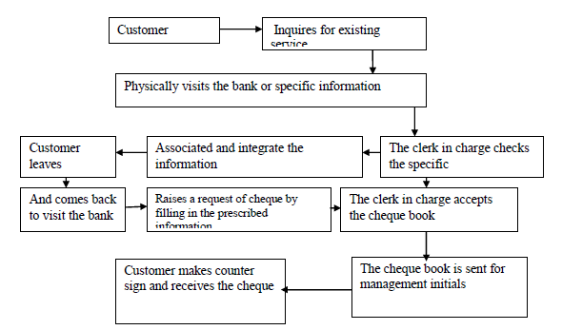

**3.3.5 PROBLEM DOMAIN**

The following problems were envisaged in the manual banking system.

1. In existing manual system, it is difficult to maintain a large scale order transaction.
2. In existing manual system huge expenditure and a lot of time is spending in communicating the information across the external bank branches and the centralized system.
3. Manually the information may not be as secure as in automated system.

**3.4 PROPOSED SYSTEM DESIGN**

In the proposed system we are concentrating the problems whatever a client faced with existing manual system. By introducing online banking management system, the client provides faster services to the customer. The transaction service, report generation services and every service is available at no delay (Sanmartin, 1997). This project is an attempt to make the task of administrator as well as customer easier. The administrator has the right to know everything. He/she has the right to know the account details of the users and bank reports. The development of the new system contains the following activities which try to automate the entire process keeping in view of the database integration approach. The administrators have great accessibility in collecting the consistent information that is very much necessary for the system to exist and coordinate.

1. The system can provide information related to the different types of accounts that are existed within the bank.
2. The system can provide the bank administration with information on the number of customers who are existence in the system.
3. The system at any point of time can provide the information related to executed transactions by the customer.
4. The system with respect to the necessities can identify all the history details of the trial participants along with their outcome of the results.

**3.4.1 THE MANUAL SYSTEM**

The research investigation and observed that the existing which is manual short-circuited in delivering their services and could not meet up with the required objectives needed as below:

1. To render accurate services to customer
2. The reduction of fraudulent activities
3. To achieve speedy processing, the guarantee of increase security
4. A higher turnover rate

**3.4.2 INPUT, OUTPUT AND ANALYSIS**

An investigation made in respect of this study relay that as a customer comes to transact business with the bank, he or she moves to the counter for inquiry. He or she then informed of what to do.

Supposing he or she wants to open saving/current account, he works directly then to the saving/current section. He is then issued a passbook in which deposits and withdrawals are made for recorded. Then the relevant data entries and other facts about the customers is given and entered into the computer system (off-line system) to be processed later. Data given by the customer forms the database of the very customer. In adding the data issued to him by the clerk/cashier.

These data are:

Account Name

Account Number

Gender

Signature

Amount deposit

Address

E-mail

Phone Number

Passport photography

Amount withdrawal

**3.4.3 THE CURRENT ISSUES INVOLVING THE FOLLOWING FACTORS**

* + Provide facility to the registration for account management.
  + Provide facility for the last transactions. This project is totally

Functioning on menu based system.

Main menu

New User

Existing user

Exit

**3.4.4 NEW USER**

This procedure collects all the personal information like name, date of birth, address, phone number, e-mail, verifying person, initial amount to be deposited from the user and provides unique identification number and account no. Using which user can make transaction after accepting only identification number and account number. It saves the information given by the user in our maintained database through file system support.

**3.4.5 EXISTING USER**

The following data items such as is enlisted in the Fig 3.3 are stored in the existing user menu:

**EXISTING USER**

New Account

Account List

Individual Account Detail

Daily Transaction

Account Update

Exit

1. **New Account**: Provides facilities to existing user to open another new account under the same identification number. And provides the same functionalities as above described in new user. It saves the information given by the user in our maintained database through file system support.
2. **Account List**: It provides list of all users associated with our banking saving system, in which name, customer identification no, phone no, e-mail. Which retrieves data from our maintained database through the file system support?
3. **Individual account details:** This method is provided to facilitate the associated user to observe current position of his or her account based on the customer identification no and account no given by the user. This retrieves data from our maintained database through the file system support.
4. **Daily Transaction:** this function provides the facilities to the associated user. For depositing, withdrawal amount through cash or cheque based on the customer identification no and account no given by the user. It saves the transaction performed by the user in our maintained database through file system support.

**3.4.6 Accounts**

The following data items, modify account, close account and exit are found in

The edit account menu:

Edit

Modify account Exit

1. **Modify Account:** this function provides the user facility of correcting his name if he has miscued it and modifying his phone no based on the customer identification no and account no given by the user. It saves the transaction performed by the user in our maintained database through file system support.
2. **Close Account**: this method provides user the facility of closing his account if he wishes to do based on the customer identification no and account no given by the user. It saves the latest account state in our banking saving system in our maintained database through file system support.
3. **Exit**: it gives the command direct to the first main menu of our project.

**3.4.7 DESIGN PROCEDURE**

Software design is both a process and model. The design process is a sequence of steps that is enables the designer to all aspects of the software to be built. Basic design principles enable the software engineer to navigate the design process. There are some principles of software design:

1. The design process should not suffer from: tunnel vision:
2. The design should be traceable to the analysis.
3. The design should not reinvent the wheel.
4. The design should minimize the intellectual distance between the software and the problem as it exists in the real world.
5. The design should exhibit uniformity and integration
6. The design should be structured to accommodate change

1. The design should be structured to degrade gently, even when aberrant data, events, or operating conditions are encountered
2. The design should be assessed for quality as it is being created, not after the fact.
3. The design should be reviewed to minimize conceptual.

**3.4.8 FLOW DIAGRAM**

The data flow diagram depicts the flow of the information within the system. The system and its user act as link with all the information following into them. Client act the source as all the request are generated by him. The record is held in the storage spaces depict by partially open rectangle. Arrows within the DFD is quit important as its records in a pictorial form all the information flow within the system. With the help of DFD we can identify the current information structure of the system. The structure of the system can thus be analyzed and it helps in making improvement within the current system.

**3.5 DATABASE DESIGN STANDARD**

The standard of the design includes

* 1. Design an input format that will enable the user capture all the necessary data online.
  2. Structure a database system that will store all the information
  3. Design a well formatted output that will present information to management in a meaningful format.
  4. Employ a top-down methodology in the design to enable a central control menu for accessing other sub system.
     1. **OUTPUT SPECIFICATION AND DESIGN**

Output from the system is in the form of document, majority of the outputs carries information relating to bank transaction operations, account statements, etc. the outputs are presented in a text format and some of the information is retrieved from the database. Some of the reports produced are: Statement of Account

Account Holders in the Bank:

Account Balance

**3.5.2 INPUT SPECIFICATION AND DESIGN**

The program designed involved some input forms in order to achieve or derived some required outputs. These forms relate to customers account opening and Transactions. The forms designed in this system are expected to be used to capture program inputs. The forms included:

1. Account opening form Know Your Customer (KYC)
2. Deposit/withdrawal form

**3.5.3 TRANSACTION FILE STRUCTURE**

The transaction file structure contains the Account name, account number of the user, amount of the transaction, date of transaction, type of transaction and cheque number.

**3.5.4 FILE DESIGN**

Access database was used in storing the information used in this project. The database was integrated into the system that the program access and update the files. In the course of the design, five tables were created in the database. The master files account table, available cash table, account type table, transaction table and user table.

**3.5.5 STRUCTURE OF THE MASTER FILE**

|  |  |  |
| --- | --- | --- |
| **Field Name** | **Type** | **Size** |
| Account No | Text | 20 |
| Name | Text | 50 |
| Address | Text | 100 |
| Sex | Text | 10 |
| Date of Birth | Date | 8 |
| Date | Date | 8 |
| Amount | Double | 8 |
| Account type | Text | 20 |
| Password | Var Char | 50 |
|  |  |  |

**3.5.6 TRANSACTION FILE**

|  |  |  |
| --- | --- | --- |
| Field Name | Type | Size |
| Account No | Text | 20 |
| Date | Date | 8 |
| Deposit | Double | 8 |
| Withdrawal | Double | 8 |
| Balance | Double | 8 |
| Teller | Var Char | 10 |
|  |  |  |

**3.5.7 AVAILABLE CASH**

|  |  |  |  |
| --- | --- | --- | --- |
| Field Name |  | Type | Size |
| Amount |  | Double | 100 |
| Name |  | Text | 30 |

|  |  |  |  |
| --- | --- | --- | --- |
| **3.5.8 ACCOUNT TYPE** |  |  |  |
|  |  |  |  |
| Field Name |  | Type | Size |
| Id |  | Int | 100 |
| Account type |  | Text | 30 |

**3.5.9 USER TABLE**

|  |  |  |
| --- | --- | --- |
| Field Name | Type | Size |
| Name | Text | 100 |
| Username | Text | 30 |
| Password | Var Char | 30 |
| Last Login | Date | 50 |

**3.6 PROGRAM FLOWCHART**

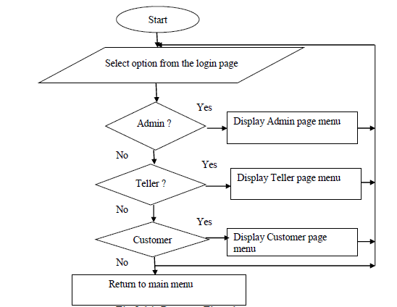

**3.6.1 ACCOUNT OPENING FLOWCHART**

Enter the account number, address, and opening amount

Store the record on the database

More entry

Yes

No

**3.6.2 BANK TRANSACTION FLOWCHART**

No

No

Yes

Yes

Yes

Display customer balance

Enter the deposit transaction

Enter withdrawal transaction

tr

Return to main menu

Balance

Withdrawal

Deposit

Selection from the sub-menu

**3.6.3 SYSTEM FLOWCHARTS**

Input Data

Output

Report

Disk storage

Input from the keyboard

C.P.U

z

**3.6.4 SYSTEM FLOWCHART**

The system flowchart: data entering are done through keyboard, processed by the central processing unit (CPU) and stored in disk storage device, output by the monitor

**3.6.5 TOP DOWN DESIGN DIAGRAM**

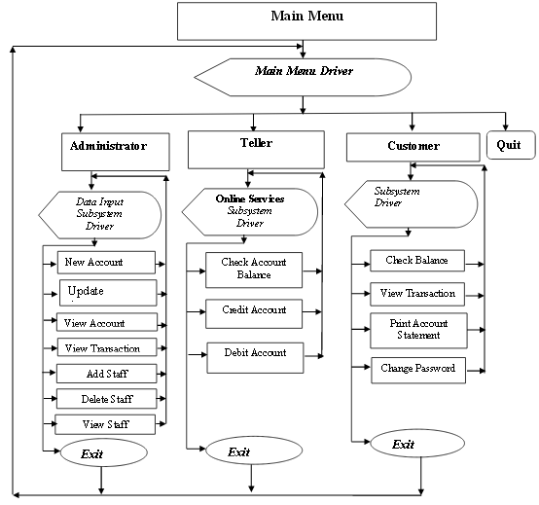

**Top-Down Design**

The top-down design for Main menu of the project.it shows the sub-system and their respective modules with their possible navigations.

**CHAPTER FOUR**

**TESTING, IMPLMENTATION AND PACKAGING**

**4.1 CHOICE OF DEVELOPMENT TOOLS**

After the analysis of this entire Software System, I choose to work with Visual basic 6.0 and MS access database as our development tools.

The choice of Visual basic 6.0 was due to the fact that it is a development platform that helps in creating web base applications at a very fast speed. It is a high level programming language that provides a very user friendly environment to write managed applications and involves less coding.

Our choice of MS access database is due to the fact that it can be used to set up a query which, when applied to a database typically returns a set of records that matches your SQL (Structured Query Language) query. It is also used to handle large databases

**4.2 SYSTEM REQUIREMENT**

In order to realize this project, the following software components were used

**4.2.1 Hardware Requirement**

In the cause of the design, the software developed needed the following hardware for an effective and efficient operation of the new system

Intel Computer System

1. At least 512 MB RAM
2. At least 40gb hard disk
3. Colored Monitor
4. An uninterruptible power supply (UPS)
5. Printer and keyboard.

**4.2.2 SOFTWARE REQUIREMENT**

The software requirement includes:

1. A window 98 or higher version for faster processing
   1. Microsoft Access
   2. Visual Basic Integrated development environment (version 6.0)
   3. Dream Weaver
   4. Font Page
2. **DATABASE IMPLEMENTATION**

Several database tables and forms were designed and implemented in this project using MYSQL (Structured Query Language) database. Each of these tables and forms has their corresponding user interface that enables the user to supply data to the system. Application table was designed for this system in order to capture the account number of each application submitted. Once an application is entered, it is automatically numbered and this is seen on top of every application / Account registration form. The account number of every application is automatically captured and stored in the account database table. In the implementation phase, the project reaches fruition. A critical phase in SLDC (System Development Life Cycle) is the successful implementation of the system; implementation simply means bringing the new system into operation. Due to our well-written documentation and user training methods developed by the experts will aid the user staff so that they can use the system efficiently and effectively. Firstly, install the software and start using. As the software has been implemented for performing all the tasks related to client information system and as a result it will reduce the complexity at work.

**4.3.1 SYSTEM SECURITY IMPLEMENTATION**

Login menu is for the user that has registered already and simply wishes to access the system. The user interface that captures data from a new user. Here the user supplies username and password which are verified for validity and existence, if they already exist, they are rejected, but if they are unique and valid, the username and password are created for that user.

**4.3.2 IMPLEMENTATION OF THE FEEDBACK TABLE DESIGN**

The implementation of the user interface that captures feedback data from users in terms of how they feel about the system, their comments, recommendations, etc. When this information is supplied, it is captured and stored in the feedback database table.

**4.3.3 IMPLEMENTATION OF TRANSACTION TABLE DESIGN**

The implementation of teller interface for crediting and debiting of an account that captured data and stored in the transaction database table.

**4.4 THE TEST PLAN**

The test plan used in this project was to test the modules, the subsystems and then the entire system. The testing was done in two parts: unit testing and integration and final testing.

**4.4.1 TEST DATA, EXPECTED VERSUS ACTUAL TEST RESULT**

At subsystem level testing, each subsystem was taken as the test data while at module level testing; each module was taken as the test data. The entire system was also taken as the test data during the system testing. During this testing, the expected result was noted, which was compared with the actual result that came up. These step by step processes were taken in all the stages of the testing process and are hereby presented in the following tables.

**4.4.2 TESTING THE DATABASE**

The database was tested by supplying sample data to each of the database tables and then verifying that the data supplied is reflected in the database.

**Account Number Testing**

|  |  |  |
| --- | --- | --- |
| **Test Data** | **Expected Result** | **Actual Result** |
|  |  |  |
|  | It was expected to Account number | Account number |
| Account Number | On every registration. | automatically appeared on |
|  |  | Every registration made. |
|  |  |  |

**4.4.3 TESTING THE ADMIN SIDE**

On testing the Admin side, all the admin side subsystems were tested as well as their individual modules. There was unit and general testing, in other words each module was tested individually and finally tested collectively as a subsystem.

Here, the individual modules were tested followed by the subsystem testing.

|  |  |  |  |  |  |
| --- | --- | --- | --- | --- | --- |
| **Test Data** | **Expected Test Result** | **Actual Test Result** | | |  |
|  |  |  | | | |
| Add Account | The application form was expected todisplay when this test data button was Clicked on. It was also expected to beready to capture inputs from the user. | The subsystem driver was able to display the app from which was ready to capture data input. | | | |
|  |  |  |  |  |  |
|  |  |  | | | |
|  |  |  |  |  |  |
|  |  |  | | | |
| Update Account  status | The user interface for making this | The user interface was displayed and data inputs were supplied. | | | |
|  | Request was expected to display andcapture inputs when supplied. |  | | | |
|  |  |  |  |  |  |
|  |  |  | | | |

**4.4.4 TESTING THE CUSTOMER SIDE**

On testing the customer side, all the client side subsystems were tested as well

as their individual modules. There was unit and general testing, in other words

each module was tested individually and finally tested collectively as a

subsystem

Main Menu Testing

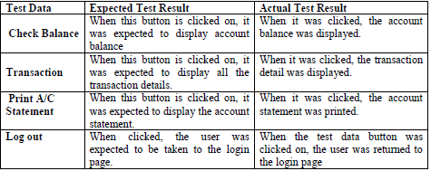

**4.4.5 INTEGRATED TESTING**

After the unit and general testing, all the modules in each subsystem were

integrated into one subsystem and tested and finally all the subsystems

were integrated into one system and equally tested.

**4.4.6 SYSTEM EVALUATION**

The system performance was satisfactory. It is very simple to use. Performance evaluation was carried out in all the testing process including the unit and general testing.

**CHAPTER FIVE**

**SUMMARY, CONCLUSION AND RECOMMENDATIONS**

**5.1 SUMMARY**

A summary of the achievements of this project, the existing system was analyzed, after which information were gathered followed by the analysis of those data. Based on the analysis, the limitations of the existing system were identified which initiated the choice of this project topic. This was followed by the system design, specification, database design, client side design, server side design, interface design and system security design. The implementation of these designed units was carried out successfully. After the design and implementation of the various units, system testing was carried out both on unit and general testing basis using test data to check the expected and actual test result. Finally, the performance evaluation of the system was certified since it is doing what it was designed to do.

**5.2 LIMITATION**

On the course of this project, many problems were encountered. Some of which includes: lack of knowledge of MySQL, this problem was solved by learning this programming Language. Lack of adequate finance to run around for the project, this was solved by getting money from some family members. Unavailability of some answers to research questions from textbooks and other sources, the solution was to interact with some Information Technology staff whom their practical experiences really helped in the project implementation.

**5.5 CONCLUSION**

The aim of this project is to provide a computerized banking system to be used in the bank. This project has been successfully completed and will go a long way to change the mode of operation of Guarantee Trust Bank specially to improve efficiency of the bank.

**5.3 RECOMMENDATIONS**

We strongly recommend that companies, industries, institutions, business organizations should start using this software as it will go a long way eradicating many of their difficulties in their various business endeavors.

**REFERENCES**

Bergstrom, R. (1994), *ATM Attached Importance and Techniques*, London: Pitman publication ltd.

Charp, S. (1994), *Networking and Telecommunications. Technical Horizons in Education, New York*: John Publishing.

Fluaghter, R. (1990), *Computerized Adaptive Testing, Hillsdale*, New York: ACM press.

Glass, H. (2000), *Interpretation of International Banking System*, New Jersey: Vintage publication.

Kingsbury, A. (2000), *Mobile Banking Services and Operations*, Birmingham: Morgan Kaufmann Publishers.

Klausmeier, J. (1984), *Networking and Microcomputers Eric Digest NY, Clearing House on Information Resources*, New York: Academic press.

Lewis, I. (2001), *Computerization of Banking Systems*, New York: Pearson Publication.

Molina, J.K. (1997), *Item Banks Information Storage and Management; Analysis of a Computer System,* Megrowhill, New York: Vintage books.

Olea, J. & Prieto, G. (1999), *Tests Information: Fundamental Application. Educational Research,* Washington DC: DP Publication ltd.

Renom, J. (1997), *Perspective Tests Adaptive Information,* New York: Yarchi Press.

Sands, W. (1997), *Computerized Adaptive Testing, American Psychological association*, Washington DC: McGraw Hill.

Vossen, G. (1991), *Data Models, Database Languages. And Database Management Systems Adison-Wesley Publishing*, New Orleans: Pitman Publication.

Wise, S., & Kingsbury, G. (2000), *Practical Issues in Developing and Maintaining a Computerized Adaptive Test: Fundamental Application*, New York: ACM Press.

**APPENDIX A**

**Private Sub cmdMainAddNew_Click()**

**frmNewAccount.Show**

**End Sub**

**Private Sub cmdMainCloseAccount_Click()**

**frmLogin.Show**

**frmMain.lblIdendification.Caption = Trim("Close Account")**

**frmLogin.frameLogin.Caption = Trim("Login :[Close Account]")**

**Login_load**

**AdmCon = 0**

**End Sub**

**Private Sub cmdMainDeposit_Click()**

**frmLogin.Show**

**frmMain.lblIdendification.Caption = Trim("Deposit")**

**frmLogin.frameLogin.Caption = Trim("Login :[Deposit]")**

**Login_load**

**AdmCon = 0**

**End Sub**

**Private Sub cmdMainExit_Click()**

**frmThankyou.Show**

**End Sub**

**Private Sub cmdMainTransfer_Click()**

**frmLogin.Show**

**frmMain.lblIdendification.Caption = Trim("Money_Transfer")**

**frmLogin.frameLogin.Caption = Trim("Login :[Money Transfer]")**

**Login_load**

**AdmCon = 0**

**End Sub**

**Private Sub cmdMainViewDetails_Click()**

**frmLogin.Show**

**frmMain.lblIdendification.Caption = Trim("View_Details")**

**frmLogin.frameLogin.Caption = Trim("Login :[View Details]")**

**Login_load**

**AdmCon = 0**

**End Sub**

**Private Sub cmdMainWithdraw_Click()**

**frmLogin.Show**

**frmMain.lblIdendification.Caption = Trim("Withdraw")**

**frmLogin.frameLogin.Caption = Trim("Login :[Withdrawal]")**

**Login_load**

**AdmCon = 0**

**End Sub**

**Private Sub Form_Load()**

**frmMain.lblIdendification.Caption = ""**

**frmLogin.frameLogin.Caption = Trim("Login :")**

**Login_load**

**AdmCon = 0**

**End Sub**

**Private Sub lblAdminR_DblClick()**

**frmLogin.Show**

**frmMain.lblIdendification.Caption = Trim("Admin")**

**frmLogin.frameLogin.Caption = Trim("Login :[Admin]")**

**Login_load**

**AdmCon = 1**

**End Sub**

**Private Sub Timer1_Timer()**

**If Image2.Visible = True Then**

**Image2.Visible = False**

**Image4.Visible = True**

**ElseIf Image4.Visible = True Then**

**Image4.Visible = False**

**Image5.Visible = True**

**Else**

**Image5.Visible = False**

**Image2.Visible = True**

**End If**

**End Sub**

**APPENDIX B**

**SAMPLE OF OUTPUT**

MAIN MENU INTERFACE

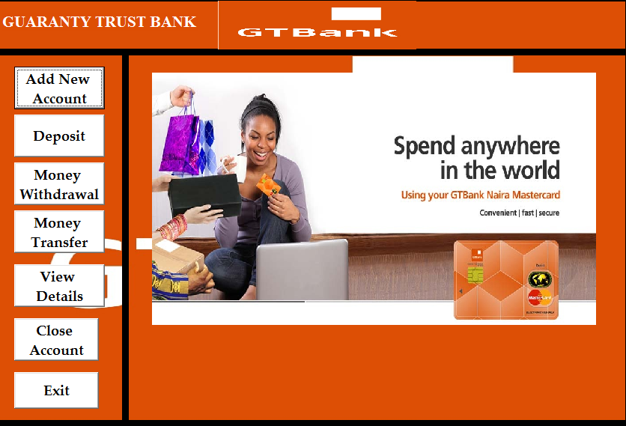

OPENING ACCOUNT INTERFACE

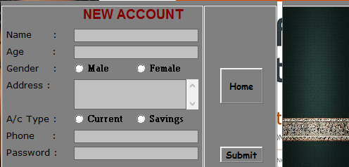

DATABASE INTERFACE

